OIL CONDITION MONITORING REPORT SLNS SAGARA

ENGINE PARTICULARS (Information provided by the customer)
 | Port Main Engine | Stbd Main Engine
Make : | SEMI PIELSTICK
Model : | 16 PA 6V 280
Sr. No’s: | 742002/8806 | 742002/8807
Date sampling : | 25 Jun 25
Sampling point : | Sump
Sampling Method : | Draining
Type of Lubricant : | Shell Gadinia S3 40
System Capacity : | 1420 Ltrs

RUNNING HRS DETAILS (Information provided by the customer)
 | Port Main Engine | Stbd Main Engine
Sample ID | M010369 | M010370
Oil Running Hours | 634.40 | 495.53
AMORH | 634.40 | 495.53
Total Running Hours of the Machinery | 29504.20 | 29483.53

ANALYSIS RESULTS

Description | Method | Fresh Oil  (As per OEM data sheet) | Uncertainty  (K=2) | Port Main Engine  (S/I-M010369) | Stbd Main Engine  (S/I-M010370)
Viscosity @ 40ºC (cSt) | ASTM D445 | 128.00 | 0.006 | 103.77 | 104.04
Viscosity @ 100ºC (cSt) | ASTM D445 | 13.70 | 0.005 | 11.71 | 12.45
Viscosity Index | ASTM D2270 | 103 | N/A | 100.58 | 112.176
Flash Point (ºC) | ASTMD 92 | 230 | 0.082 | 200 | 206

Elemental Concentration as per ASTM D5185 (ppm)

Element | Maximum Permissible Limit | Uncertainty  (K=2) | Fresh Oil Sample | Port Main Engine  (S/I-M010369) | Stbd Main Engine  (S/I-M010370)
Fe | 80 | 0.15 | < 1.000 | 13.773 | 18.468
Cr | 10 | 0.18 | < 1.000 | < 1.000 | < 1.000
Si | 15 | 0.17 | < 1.000 | < 1.000 | < 1.000
Al | 20 | 0.28 | < 1.000 | 2.161 | 2.373
Pb | 20 | 0.13 | < 1.000 | 2.242 | 1.802
Cu | 25 | 0.17 | < 1.000 | 8.550 | 5.886
Sn | 10 | 0.20 | < 1.000 | 2.208 | 1.395
Ni | 10 | 0.08 | < 1.000 | < 1.000 | < 1.000

TREND ANALYSIS WITH PREVIOUS REPORTS
 |  | Fresh Oil Sample | Port Main Engine
 |  | Fresh Oil Sample | S/I-M000151 | S/I-M000246 | S/I-M000329 | S/I-M000473 |  | S/I-M000577 | S/I-M001351 | S/I-M001701 | S/I-M001945 | S/I-M002641 | S/I-M003355 | S/I-M003765 | S/I-M005072 | S/I-M005961
Oil Running Hrs |  | - | 1536.58 | 306.20 | 479.50 | 716.45 |  | 867.15 | 1507.20 | 433.45 | 471.50 | 967.17 | 1212.50 | 250.00 | 456.10 | 502.05
T/R/H of Machinery |  | - | 25580.05 | 25886.25 | 26059.55 | 26296.50 |  | 26447.20 | 27087.20 | 27471.50 | 27559.55 | 28055.20 | 28300.15 | 28550.15 | 28756.25 | 28,802.20
Basic Properties
Viscosity @ 40ºC (cSt) |  | 128.00 | 133.00 | 113.95 | 129.96 | 119.84 |  | 117.61 | 111.82 | 126.52 | 122.47 | 111.19 | 91.14 | 111.26 | 101.39 | 99.17
Viscosity @ 100ºC (cSt) |  | 13.70 | 15.31 | 12.33 | 13.86 | 13.20 |  | 13.36 | 13.05 | 13.25 | 13.32 | 12.46 | 10.34 | 12.24 | 11.56 | 11.69
Viscosity Index |  | 103 | N/A | N/A | N/A | 104.53 |  | 109.28 | 111.58 | 98.58 | 103.45 | 103.38 | 93.64 | 99.94 | 101.17 | 106.33
Total Base No. mgKOH/g |  | 10.48* | N/A | N/A | N/A | 10.85 |  | 10.43 | 9.44 | 10.21 | 10.04 | 9.34 | 8.57 | 9.47 | 8.17 | N/C
Water content % |  | < 0.2 | N/A | N/A | N/A | < 0.1 |  | < 0.1 | N/A | N/A | N/A | N/A | < 0.1 | < 0.1 | <0.1 | N/C
Flash Point (ºC) |  | 230 | N/A | N/A | N/A | N/A |  | N/A | N/A | N/A | N/A | N/A | 175 | 195 | 190 | N/C
Elemental Concentration as per ASTM D5185 (ppm)
Element | Max. Permissible Limit
Fe | 80 | < 1.000 | 12.924 | 5.024 | 5.928 | 4.027 | 5.814 |  | 8.267 | 7.062 | 8.222 | 12.483 | 8.608 | 3.330 | 7.927 | 6.306
Cr | 10 | < 1.000 | <1.000 | <1.000 | <1.000 | < 1.000 | < 1.000 |  | < 1.000 | < 1.000 | < 1.000 | < 1.000 | < 1.000 | < 1.000 | < 1.000 | < 1.000
Si | 15 | < 1.000 | 4.069 | 4.798 | 4.941 | 3.388 | 3.185 |  | < 1.000 | 3.998 | 5.322 | 2.000 | 2.639 | < 1.000 | < 1.000 | 10.340
Al | 20 | < 1.000 | 1.896 | 2.870 | 2.190 | < 1.000 | < 1.000 |  | 2.051 | < 1.000 | 1.728 | 2.187 | 3.221 | 2.625 | < 1.000 | 8.013
Pb | 20 | < 1.000 | < 1.000 | 1.460 | < 1.000 | < 1.000 | < 1.000 |  | < 1.000 | < 1.000 | < 1.000 | < 1.000 | 2.092 | < 1.000 | < 1.000 | < 1.000
Cu | 25 | < 1.000 | 10.988 | 2.082 | 1.945 | 1.286 | 1.816 |  | 2.503 | 2.058 | 3.374 | 5.149 | 3.102 | < 1.000 | 2.510 | 3.104
Sn | 10 | < 1.000 | < 1.000 | < 1.000 | < 1.000 | < 1.000 | < 1.000 |  | < 1.000 | < 1.000 | < 1.000 | < 1.000 | < 1.000 | < 1.000 | < 1.000 | < 1.000

 |  | Fresh Oil Sample |  | Port Main Engine
 |  |  |  | S/I-M006707 |  | S/I-M007355 (after MOH) | S/I-M007783 | S/I-M008078 | S/I-M009085 | S/I-M009144 | S/I-M009612 | S/I-M009801 | S/I-M010369
Oil Running Hrs |  | - |  | 552.05 |  | 08.00 | 37.55 | 89.70 | 127.15 | 162.05 | 500.00 | 604.05 | 634.40
T/R/H of Machinery |  | - |  | 28852.20 |  | 28,877.20 | 28907.25 | 28959.30 | 29007.05 | 29033.35 | 29366.55 | 29473.45 | 29504.20
Basic Properties
Viscosity @ 40ºC (cSt) |  | 128.00 |  | 97.69 |  | 125.96 | 120.68 | 118.46 | 115.82 | 115.10 | 105.44 | 102.95 | 103.77
Viscosity @ 100ºC (cSt) |  | 13.37 |  | 11.24 |  | 13.45 | 13.32 | 13.21 | 13.06 | 12.90 | 11.74 | 11.49 | 11.71
Viscosity Index |  | 103 |  | 100.71 |  | 101.55 | 110.67 | 100.98 | 107.03 | 105.45 | 99.08 | 98.16 | 100.58
Total Base No. mgKOH/g |  | 10.48* |  | N/C |  | 10.30 | 10.38 | N/C | 10.12 | 10.02 | 9.71 | N/C | N/C
Water content % |  | < 0.2 |  | N/C |  | < 0.1 | N/C | N/C | < 0.1 | < 0.1 | < 0.1 | N/C | N/C
Flash Point (ºC) |  | 230 |  | N/C |  | 220 | 210 | N/C | 208 | 210 | 208 | 185 | 200
Elemental Concentration as per ASTM D5185 (ppm)
Element | Max. Permissible Limit
Fe | 80 |  | < 1.000 | 3.365 |  | 5.587 | 8.363 | 4.398 | 17.138 | 32.701 | 21.139 | 14.905 | 13.773
Cr | 10 |  | < 1.000 | < 1.000 |  | < 1.000 | < 1.000 | < 1.000 | < 1.000 | < 1.000 | < 1.000 | < 1.000 | < 1.000
Si | 15 |  | < 1.000 | 3.843 |  | 1.263 | 7.620 | 4.091 | 4.177 | < 1.000 | 4.683 | 3.272 | < 1.000
Al | 20 |  | < 1.000 | 1.235 |  | 1.198 | 1.604 | < 1.000 | 1.767 | 3.823 | 1.998 | 1.576 | 2.161
Pb | 20 |  | < 1.000 | < 1.000 |  | < 1.000 | < 1.000 | < 1.000 | 1.501 | 2.600 | 4.893 | 1.628 | 2.242
Cu | 25 |  | < 1.000 | 1.722 |  | 3.281 | 6.080 | 2.280 | 4.780 | 6.055 | 4.077 | 3.998 | 8.550
Sn | 10 |  | < 1.000 | < 1.000 |  | < 1.000 | < 1.000 | < 1.000 | < 1.000 | < 1.000 | 1.856 | 1.305 | 2.208
Ni | 10 |  | < 1.000 | < 1.000 |  | < 1.000 | < 1.000 | N/C | < 1.000 | < 1.000 | < 1.000 | < 1.000 | < 1.000

 |  | Fresh Oil Sample | Stbd Main Engine
 |  | Fresh Oil Sample | S/I-M000152 | S/I-M000247 | S/I-M000330 | S/I-M000474 | S/I-M000578 | S/I-M000758 | S/I-M001352 | S/I-M001702 | S/I-M001946 | S/I-M002083 | S/I-M002642 | S/I-M003356 | S/I-M003766 | S/I-M004613 | S/I-M005962
Oil Running Hrs |  | - | 1514.49 | 355.00 | 494.40 | 726.55 | 886.50 | 1101.30 | 1520.20 | 381.25 | 495.50 | 668.42 | 994.35 | 1199.05 | 250.00 | 500.00 | 577.00
T/R/H of Machinery |  | - | 25518.20 | 25873.20 | 26013.00 | 26247.20 | 26407.15 | 26618.50 | 27037.20 | 27469.15 | 27533.55 | 27730.45 | 28032.40 | 28236.50 | 28486.50 | 28736.50 | 28813.50
Basic Properties
Viscosity @ 40ºC (cSt) |  | 128.00 | 104.98 | 110.27 | 108.94 | 93.96 | 112.23 | 105.90 | 106.22 | 117.76 | 116.86 | 112.97 | 108.99 | 91.53 | 104.49 | 106.58 | 84.19
Viscosity @ 100ºC (cSt) |  | 13.70 | 12.77 | 12.01 | 12.60 | 11.37 | 13.34 | 12.38 | 12.57 | 12.90 | 13.03 | 12.83 | 12.36 | 10.66 | 11.88 | 11.89 | 10.68
Viscosity Index |  | 103 | N/A | N/A | N/A | 109.03 | 115.32 | 108.60 | 111.203 | 102.5 | 105.42 | 106.85 | 104.44 | 99.16 | 102.93 | 99.98 | 111.27
Total Base No. mgKOH/g |  | 10.48* | N/A | N/A | N/A | 10.64 | 10.15 | 10.02 | 9.68 | 10.11 | 9.82 | 8.23 | 9.69 | 8.72 | 9.85 | 8.74 | N/C
Water content % |  | < 0.2 | N/A | N/A | N/A | < 0.1 | < 0.1 | < 0.1 | N/A | N/A | N/A | N/A | N/A | < 0.1 | < 0.1 | <0.1 | N/C
Flash Point (ºC) |  | 230 | N/A | N/A | N/A | N/A | N/A | N/A | N/A | N/A | N/A | N/A | N/A | 180 | 195 | 190 | N/C
Elemental Concentration as per ASTM D5185 (ppm)
Element | Max. Permissible Limit
Fe | 80 | < 1.000 | 13.278 | 6.667 | 7.768 | 5.879 | 7.585 | 10.830 | 7.152 | 5.617 | 3.622 | 4.898 | 9.354 | 13.005 | 3.583 | 2.128 | 10.187
Cr | 10 | < 1.000 | <1.000 | <1.000 | < 1.000 | < 1.000 | < 1.000 | < 1.000 | < 1.000 | < 1.000 | < 1.000 | < 1.000 | < 1.000 | < 1.000 | < 1.000 | < 1.000 | < 1.000
Si | 15 | < 1.000 | 4.042 | 4.566 | 4.003 | 3.115 | 4.395 | 6.383 | < 1.000 | 4.256 | 4.334 | < 1.000 | < 1.000 | 1.860 | < 1.000 | < 1.000 | 9.825
Al | 20 | < 1.000 | 1.421 | 2.070 | 2.500 | < 1.000 | 1.721 | 1.852 | 1.234 | 1.107 | 1.191 | 1.447 | 1.768 | 3.453 | 2.248 | < 1.000 | 7.589
Pb | 20 | < 1.000 | 1.015 | < 1.000 | < 1.000 | < 1.000 | < 1.000 | < 1.000 | < 1.000 | < 1.000 | < 1.000 | 1.993 | < 1.000 | 1.280 | < 1.000 | < 1.000 | < 1.000
Cu | 25 | < 1.000 | 19.906 | 3.831 | 4.581 | 3.380 | 3.102 | 4.335 | 3.039 | 1.885 | 2.361 | 3.281 | 5.772 | 4.219 | < 1.000 | 1.026 | 3.663
Sn | 10 | < 1.000 | < 1.000 | < 1.000 | < 1.000 | < 1.000 | < 1.000 | < 1.000 | < 1.000 | < 1.000 | < 1.000 | < 1.000 | < 1.000 | < 1.000 | < 1.000 | < 1.000 | < 1.000

 |  | Fresh Oil Sample | Stbd Main Engine
 |  | Fresh Oil Sample | S/I-M006708 | S/I-M007356 | S/I-M007784  (after MOH) | S/I-M008078 | S/I-M009086 | S/I-M009145 | S/I-M009613 | S/I-M010370
Oil Running Hrs |  | - | 677.00 | 701.50 | 28.45 | 80.10 | 124.15 | 159.03 | 500.00 | 495.53
T/R/H of Machinery |  | - | 28863.50 | 28,888.20 | 28917.25 | 28891.10 | 29012.55 | 29058.05 | 29384.33 | 29483.53
Basic Properties
Viscosity @ 40ºC (cSt) |  | 128.00 | 106.61 | 102.98 | 119.74 | 118.36 | 117.28 | 116.30 | 106.15 | 104.04
Viscosity @ 100ºC (cSt) |  | 13.70 | 11.79 | 12.01 | 13.47 | 13.13 | 13.10 | 13.02 | 12.38 | 12.45
Viscosity Index |  | 103 | 98.52 | 102.36 | 108.48 | 101.41 | 105.98 | 105.89 | 108.28 | 112.176
Total Base No. mgKOH/g |  | 10.48* | N/C | N/C | 10.14 | N/C | 10.02 | 10.05 | 9.54 | N/C
Water content % |  | < 0.2 | N/C | N/C | < 0.1 | N/C | < 0.1 | < 0.1 | < 0.1 | N/C
Flash Point (ºC) |  | 230 | N/C | 180 | 210 | N/C | 208 | 208 | 206 | 206
Elemental Concentration as per ASTM D5185 (ppm)
Element | Max. Permissible Limit
Fe | 80 | < 1.000 | 6.944 | 8.346 | 8.121 | 6.639 | 15.958 | 36.200 | 22.759 | 18.468
Cr | 10 | < 1.000 | < 1.000 | < 1.000 | < 1.000 | 2.021 | < 1.000 | < 1.000 | < 1.000 | < 1.000
Si | 15 | < 1.000 | 5.599 | 1.179 | 6.993 | 4.735 | 2.376 | 1.883 | 3.347 | < 1.000
Al | 20 | < 1.000 | 1.485 | 1.195 | 1.195 | < 1.000 | 1.645 | 1.833 | 2.314 | 2.373
Pb | 20 | < 1.000 | < 1.000 | < 1.000 | < 1.000 | < 1.000 | 1.630 | 2.239 | 2.741 | 1.802
Cu | 25 | < 1.000 | 1.466 | < 1.000 | 3.387 | < 1.000 | 4.861 | 3.461 | 4.618 | 5.886
Sn | 10 | < 1.000 | < 1.000 | < 1.000 | < 1.000 | < 1.000 | < 1.000 | < 1.000 | 1.957 | 1.395
Ni | 10 | < 1.000 | < 1.000 | < 1.000 | < 1.000 | N/C | < 1.000 | < 1.000 | < 1.000 | < 1.000

N/C-Not Conducted
Viscosity Port M/E
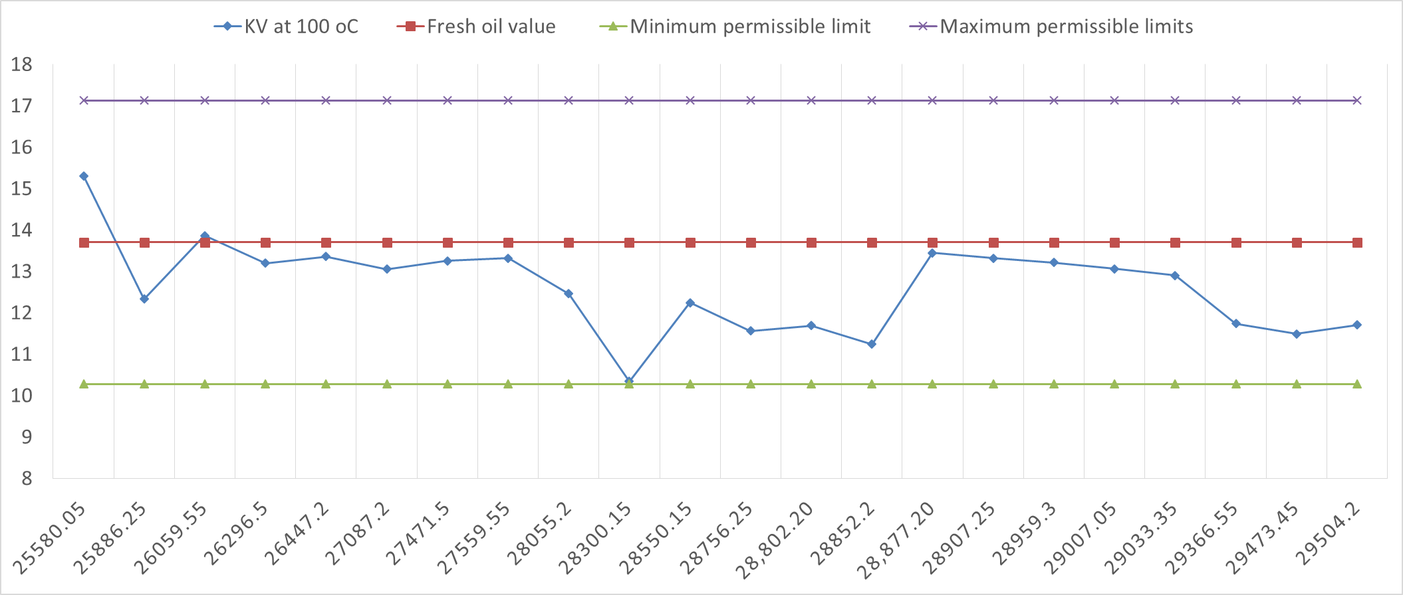
AT 40 ºC AT 100 ºC
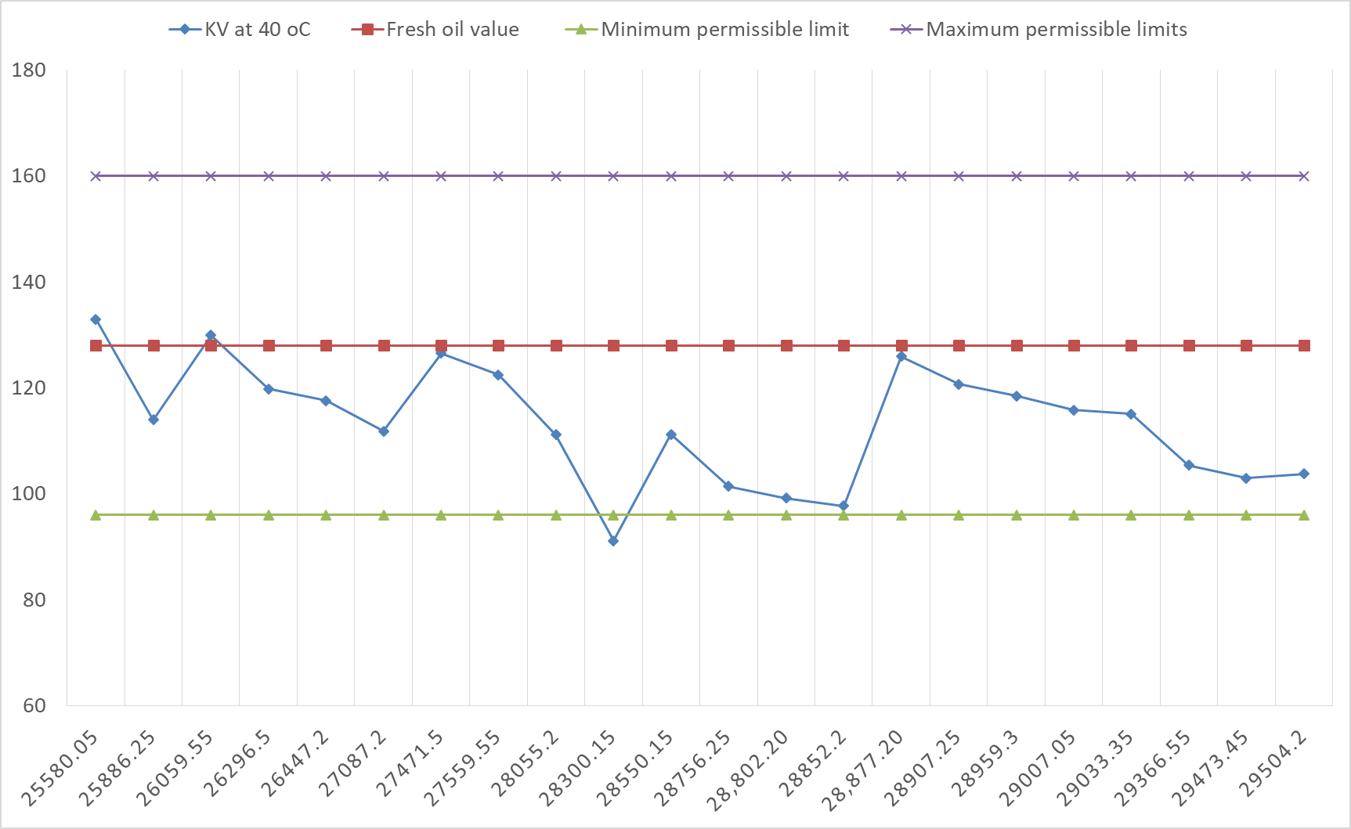

cSt
cSt

Total Running Hrs
Total Running Hrs
Total Running Hrs

Viscosity Stbd M/E
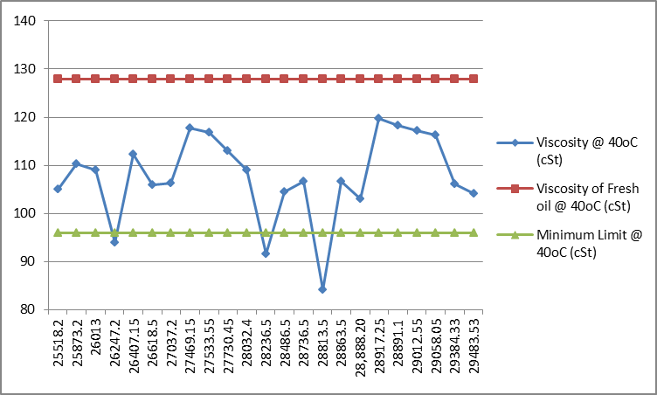
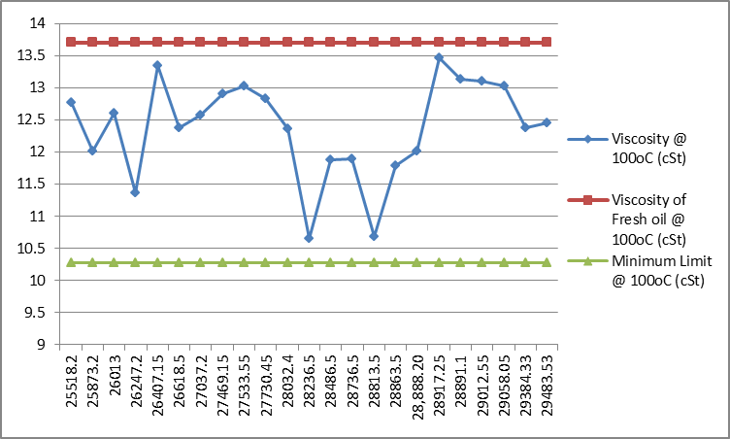
AT 40 ºC AT 100 ºC

cSt
cSt

Total Running Hrs
Total Running Hrs
Total Running Hrs

Wear Metals
Total Running Hrs
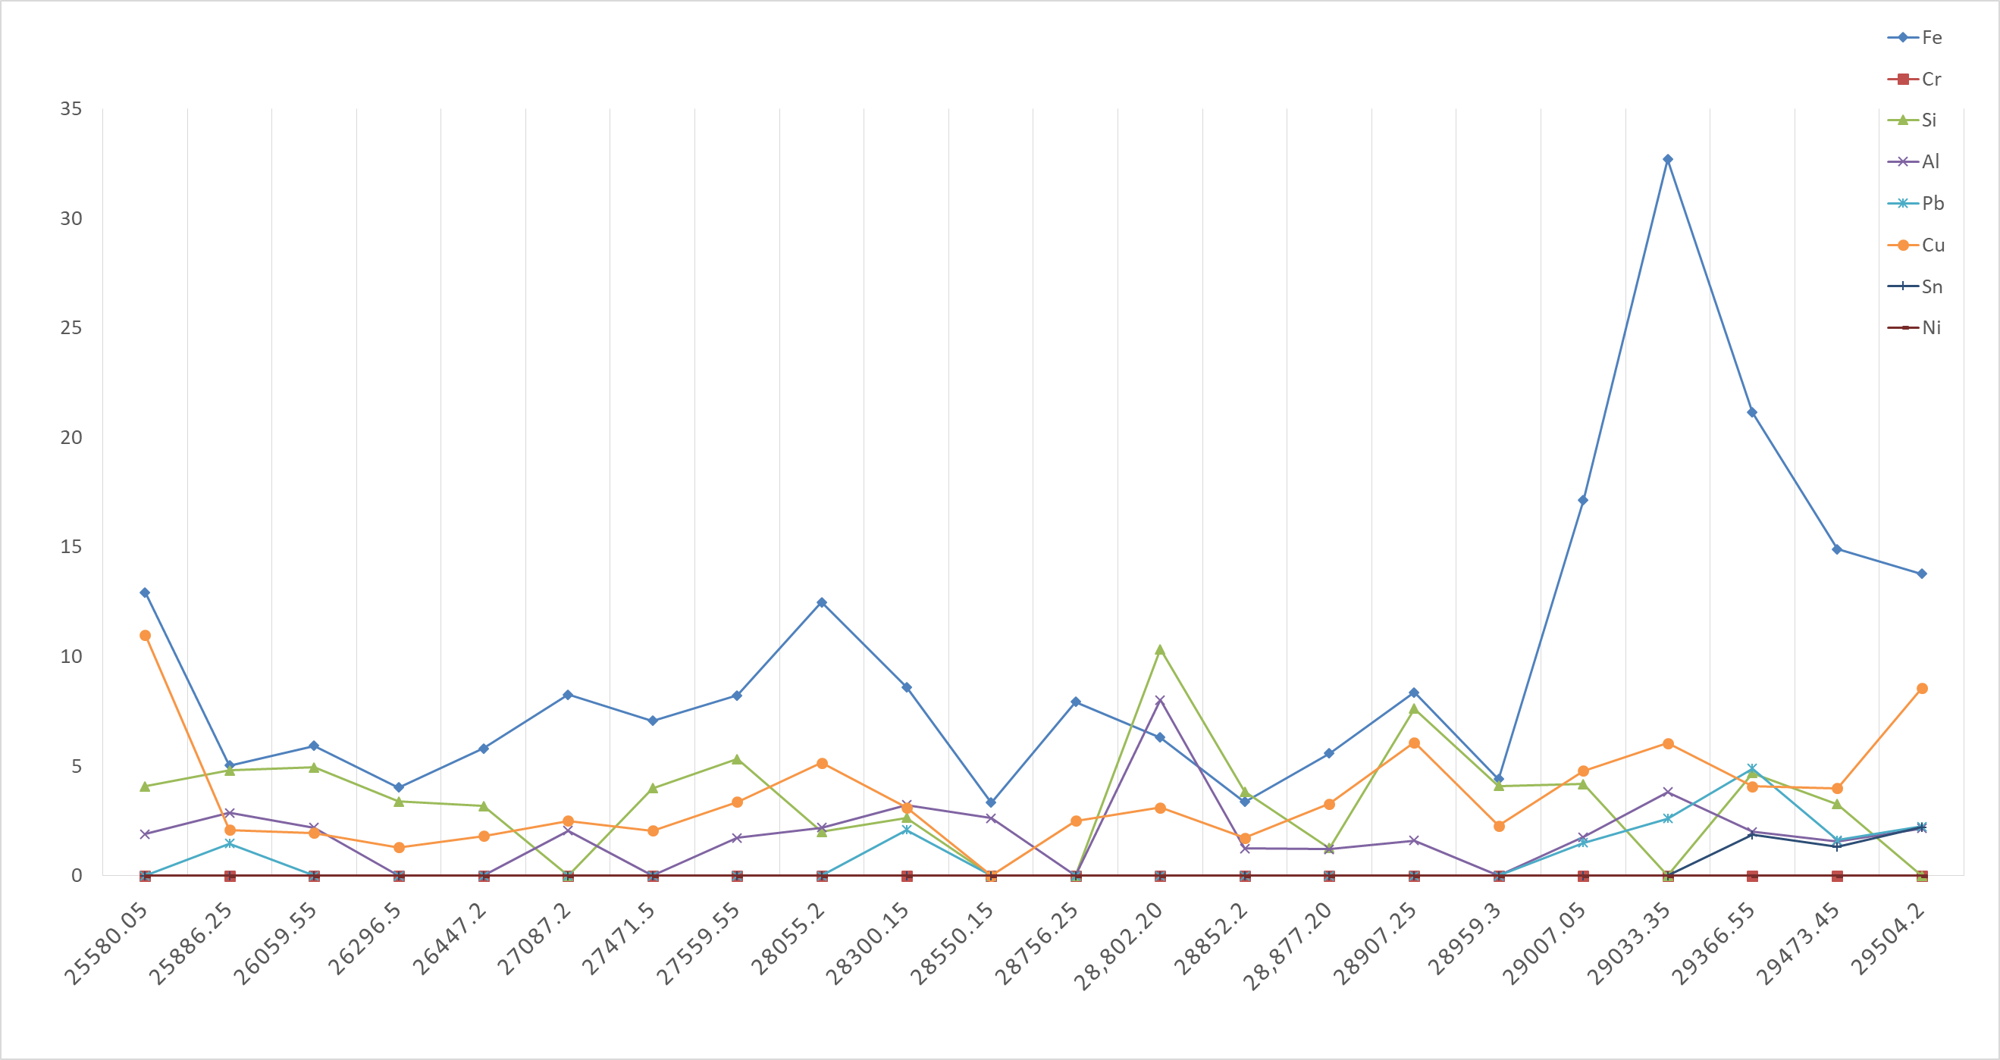
Port Stbd
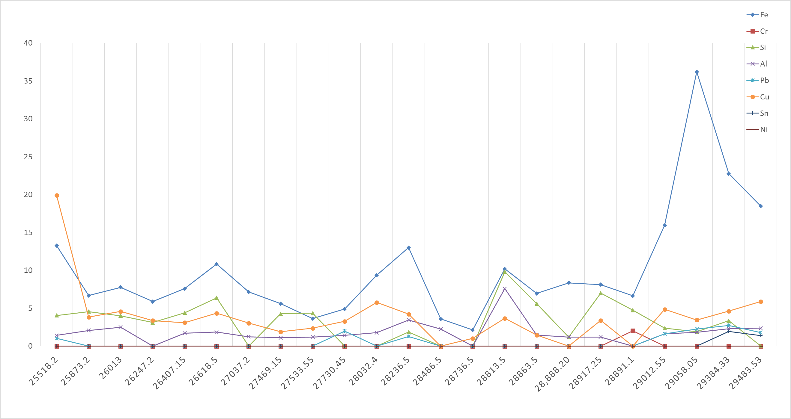

ppm
ppm

Total Running Hrs

Total Running Hrs
Total Running Hrs

